|  |  |
| --- | --- |
| Adaptive Suspension System using MR Dampers Name: Viraj GuptaUnique ID: 2005557 |  |
|  |  |

Contents

Name: Viraj Gupta 1

Unique ID: 2005557 1

1. Introduction 3

1.1: What is a vehicle suspension system? 3

1.2: Classification of suspension systems 3

2. Market Analysis 6

Citroen: 6

Ford: 6

Lexus: 7

Mercedes-Benz: 7

Audi: 7

Aston Martin: 7

3. Literature Review 8

3.1: Servo / Solenoid Valve Dampers 8

3.2: Electrorheological and Magnetorheological fluids 8

4. Simulink Model Details 11

4.1 Output Explanation 12

References: 14

List of Figures

Figure 1: Passive Suspension System 4

Figure 2: Semi-Active Suspension System 6

Figure 3: Property of ER fluids 9

Figure 4: Property of MR Fluids 9

Figure 5: MR Damper 10

Figure 6: Output of the model 12

## 1. Introduction

### 1.1: What is a vehicle suspension system?

A suspension system in the vehicle has two major roles:

* *Improve the handling of the vehicle:* Dynamic manoeuvers like cornering result in body roll. For instance, upon turning towards the left, load transfer towards the right side of the body occurs and vice-versa. This transfer of load results in the body being slightly tilted towards the right. A suspension system would be responsible for keeping body roll minimum and within acceptable limits.
* *Improve the ride quality:* If throughout the globe, if the roads were perfectly flat and smooth, without any bumps, holes, elevation, etc., the need for suspension systems would have been minimal. However, this is not the case and a vehicle does experience bumps throughout the duration of the ride. The suspension system is responsible for preventing the vertical movement of wheels to being transferred to the chassis and vehicle body.

### 1.2: Classification of suspension systems

Without getting into the implementation details of each system, the systems can be classified into 3 groups:

1. Passive
2. Active
3. Semi-Active

#### 1.2.1 Passive Suspension Systems

They comprise of a traditional spring and oil damper. The stiffness of the spring and the damping coefficient of the oil damper remain constant and cannot be changed. Hence the system becomes less costly and less complex. The reliability of the system is very high.

The drawback of such a system is its inability of adjusting to the road conditions and the driving style of the driver depending upon the road conditions. For example, Cars built for city roads where there is constant braking and lesser speeds during cornering have a softer suspension and sports cars which are built for aggressive driving tend to have a stiffer suspension.

**Softer suspension** will improve ride quality, as the wheels will be able to compress the springs a lot more as they cross the bumps of the road. The wheel can be moved in the vertical direction a bit more freely and the spring is soft enough to absorb that movement. Hence a very low percentage of the vertical movement of the wheel will be transferred to the body and chassis, thus providing a more comfortable and less bumpy ride.

However, upon aggressive cornering, the outside half of the vehicle will become excessively tilted, because of the softer suspension that results in easy compression of the springs, and hence the passengers will experience excessive body roll.

**Stiffer suspensions** improve the handling of the vehicle. Upon cornering, because the springs are stiffer, the outside of the vehicle won’t be able to compress the springs at the same rate. Hence the body roll would be minimized and the vehicle can be driven more aggressively and pushed into corners with greater speed. Hence sports cars have a stiffer suspension.

On the contrary, the ride quality will eventually deteriorate as because of the stiffer suspension, whenever the wheels encounter a bump, the springs won’t be compressed enough and a large percentage of the vehicle’s upward movement will be transferred to the chassis and the body.

Hence, in passive suspension systems, there is always a compromise made on ride quality and handling.

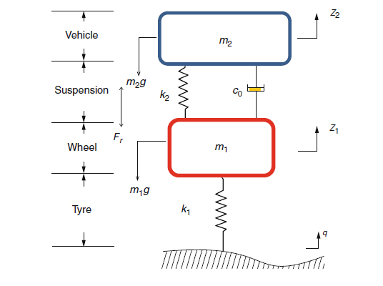

Figure 1: Passive Suspension System

In Figure 1, k1 is the spring stiffness of the tire. m1 is the unsprung mass i.e. wheels, wheel hub, axles, etc., k2 is the spring stiffness of the suspension spring, co is the damping coefficient of the damper, m2 is the sprung mass i.e. chassis, body, etc.

Softer suspensions tend to have a softer spring and a lower damping coefficient. Stiffer suspensions tend to have a stiffer spring and a higher damping coefficient. k2 and co can’t be changed in passive suspension systems.

#### 1.2.2 Active Suspension Systems

Instead of having physical springs and dampers, an electrical motor can be used. The motor can lift perform the job of the spring as well as the damper and can thus replace them. Upon encountering a bump, the wheel of the vehicle can be raised, keeping the chassis flat. Hence no vertical motion of the wheel s transferred to the chassis and thus optimal vehicle ride and handling is ensured.

However, a system like this comes with its own disadvantage. For example, if the electric motor fails, because there are no physical springs and dampers, the car would be not suitable to be driven. It also consumes a lot of power as the electric motor would be operational throughout the duration of the ride.

Hence, such a system is rarely used in any automobile, because the reliance on an electric motor to do the job of springs and dampers isn’t feasible.

#### 1.2.3 Semi – active suspension systems

These systems incorporate the physical springs and dampers and they also have a control algorithm to control the damping coefficient of the damper. This external actuating element which controls the properties of the damper comprise of the semi-active part and has proven to be a better alternative compared to both the systems discussed above.

There are many control algorithms that can help one control the damping coefficient of the vehicles and depending upon the type of the vehicle and its use, the most efficient control algorithm is thus selected.

A few technologies employed in modern dampers are:

* Electrorheological fluids and Magnetorheological fluids
* Solenoid valves

Because semi-active systems provide safety, better economy and don’t need a large power supply, there are the preferred systems for high-performance automobiles. However, because of their higher cost, implementing them in the lower-segment or mid-range segment vehicles would be difficult.

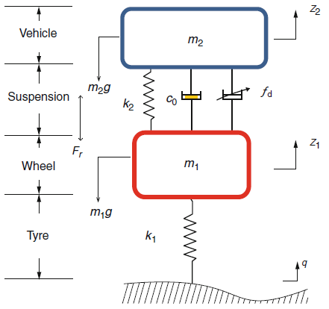

Figure 2: Semi-Active Suspension System

In Figure 2, k1 is the spring stiffness of the tire. m1 is the unsprung mass i.e. wheels, wheel hub, axles, etc., k2 is the spring stiffness of the suspension spring, co is the damping coefficient of the damper, m2 is the sprung mass i.e. chassis, body, etc. and fd is the added force to the damper from the semi-active element.

The semi-active suspension systems are thus further discussed throughout the report.

## 2. Market Analysis

Market Analysis for the semi-active suspension technologies for a few OEMs has been done. The OEMs have been chosen based on the availability of information about their systems and their implementation, so as to provide a clearer picture about the different semi-active suspension technologies available. The technologies available for implementing semi-active suspension technologies are discussed in the Literature Review.

### Citroen:

Citroen came out with the world’s first semi-active suspension system in the 1955 Citroen DS. Now, in the present age, DS is an independent Car brand, which was earlier a sub-brand of Citroen.

Presently, Citroen uses an adaptive scan suspension that scans the road ahead for about 20 metres ahead and adjusts the damping coefficient of the dampers, making them softer or stiffer. The camera is placed at the back of the rear-view mirror, which allows for the road to be scanned effectively.

### Ford:

Ford launched its semi-active suspension system in 2007.

It was called the Interactive Vehicle Dynamic Control (IVDC) and was first introduced in the ford Mondeo. It was capable of adjusting the damper characteristics more than 10 times a second according to the road conditions.

In 2017, Ford launched the Continuously Controlled Damping system (CCD), which now is the semi-active suspension technology available in the higher-end line of Vehicles.

### Lexus:

In 2006, Lexus came out with Active Power Stabilizer Suspension System (APSSS), which was used in all of their vehicles till 2014. After that the Adaptive Variable Suspension was introduced by Lexus which still runs all their models till date.

### Mercedes-Benz:

In 1999, Mercedes-Benz came out with their first version of Active Body Control (ABC) in their CL-class. Since then until today, their version of ABC has changed and improved multifold and now their vehicles come with a new version called E-Active ABC. E-Active ABC comes with an airmatic suspension and allows one to change the damping characteristics of each wheel and not just the whole car at once. Hence providing an even better handling capabilities.

### Audi:

Audi brought in their first semi-active suspension in 2007 with their R8. Since then improvements have been made to the system and now all Audi vehicles have what Audi call Adaptive Damping Suspension. This system also allows individual control of the wheels and adjusts the damping coefficient using electromechanical methods.

### Aston Martin:

Aston Martin has used a triple volume air suspension with Adaptive Damper Control in their new DBX. The system not only acts as a semi-active suspension system but also can raise the DBX to a max height of 50mm from its normal ride height at the suspensions maximum elongation.

From the market analysis, it can be concurred that all major OEMs mostly use semi-active suspension systems when it comes to vehicles in the luxury segment or the higher-end segment. Even though the OEMs don’t disclose the actual implementation of the suspension, the technologies discussed in the Literature Review form the major techniques used for implementing these systems.

## 3. Literature Review

In this section, the techniques and methods that are used for implementing semi-active suspensions are discussed.

### 3.1: Servo / Solenoid Valve Dampers

Solenoid Valves are used everywhere. Their use can be found large cooling systems, bottling plants, vehicle dampers, etc. Their operating principle is really simple. They have a valve through which the fluid is allowed to pass. The opening and closing of the valve can be controlled, which can thus control the amount of fluid flowing through the valve.

In a two-state valve, the valve can be either fully open or fully closed. In a multi-state valve, the valve position can be controlled, thus regulating the flow of the fluid.

In dampers, the size of the orifices of the pistons can be adjusted. If each orifice is a solenoid valve, the size of the orifice can be controlled, by passing varying magnitudes of electrical current. When the valve is wide open, the fluid will flow through easily, thus resulting in a softer suspension. However, when the valve is closed, or just partially open, the pressure of the fluid shall increase, which would slow down the speed of the piston, resulting in a stiffer suspension. Thus, the damping characters of the suspension can be adjusted by varying the size of the orifices of the piston.

### 3.2: Electrorheological and Magnetorheological fluids

Rheology is the study of flow and deformation of matter. This branch of physics basically deals with the flow of Non-Newtonian fluids.

Electrorheological fluids, referred to as ER fluids from now on, are simply colloidal suspension of particles. The fluids need to be a non-conducting and the particles need to be di-electric in nature. Without any application of electric field, the particles are flowing throughout the fluid in a random order and the viscosity of the fluid remains constant. Whenever an electric field is applied, the particles in the fluid align themselves in the direction of the electric field, forming large chain of particles in the process. These long chains of particles hamper the flow of the fluid and thus increase the resistance towards the flow. Essentially increasing the viscosity of the fluid and changing its rheological properties.

Magnetorheological fluids, referred to as MR fluids from now on, are similar to ER fluids in composition. They have ferromagnetic materials that are micron-sized dispersed in a fluid. Under zero-field, they are free to move but under the application of a magnetic field, they form long chains of particles that hamper the movement of the fluid, thus increasing viscosity.

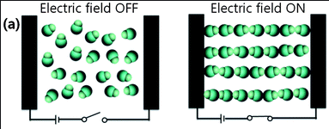

Figure 3: Property of ER fluids

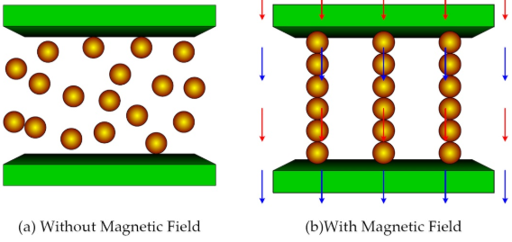

Figure 4: Property of MR Fluids

From figure 3 and 4, it can be seen that upon the action of respective fields, the rheological properties of the fluids tend to change. Owing to this behavior, these class of fluids can be employed in semi-active suspension systems as damper fluids.

In automotive domain, MR dampers are now chosen over the ER dampers because of their higher yield stress values and operating temperature range.

#### 3.2.1 MR Dampers

A damper consists of a piston moving in a container filled with a fluid. The piston has holes or orifices that allow the fluid to pass.

Upon experiencing a shock, the spring and the damper set up experiences a vertical movement. This moves the piston of the damper through the fluid. During the motion of the fluid passing through the orifices of the piston, heat is generated due to friction. Hence the kinetic energy of the moving piston is dissipated as heat energy and energy of the vertical motion is reduced or damped, reducing chassis movement.

To convert these dampers to semi-active dampers, the fluid comprises of a MR fluid. Coils are also employed in the cylinder, either at the piston or at the ends of the container. Upon applying an electric current, the coils can be converted to an electromagnet, whose strength can be controlled by controlling the electric current. Varying the strength of the magnetic field can vary the viscosity of the fluid, thus providing different damping coefficients. These changes can be made in real-time.

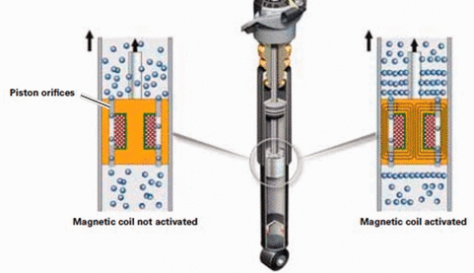

Figure 5: MR Damper

After activating the current through the coils, the ferromagnetic materials form strong chains, preventing the flow of fluids. In this case, the coils are located at the pistons, thus increasing the viscosity of the fluid near the piston, improving efficiency.

In essence, upon applying the magnetic field, the MR fluid turns into a semi-solid from the fluidic state, which results from the long chains formed of the Ferromagnetic materials. Since this change happens in milliseconds, it is possible to use them in real-time Semi-active damper systems.

Based upon construction, MR Dampers can be classified into two types:

* *Mono Tube Dampers*: They comprise of only one cylinder which contains the piston and the MR fluid. The piston moves through the MR fluid creating a damping effect. No air molecules exist in this cylinder.
* *Twin Tube Dampers*: They comprise of two tubes. One inner and one outer. The inner tube comprises of the piston, the fluid and the foot-valve. The outer container comprises of the excess fluid and air molecules. During the upward movement of the piston, the fluid from the outer tube flows through the foot valve to the inner tube. During the downward movement, the fluid from the inner tube flows to the outer tube.

#### 3.2.2. MagneRide

It was developed by Delphi Automotive and now is controlled by the BWI group. Initially it was employed in the luxury and sports vehicles such as Cadillac STS and Chevrolet Corvette in the beginning of 2003. MagneRide suspension has also been seen on the Audi R8, Audi TT, Land Rover vehicles, Ford Mustang, Ferrari 599, Ferrari California T, etc. to name a few.

The MagneRide system uses MR fluids in their damper cylinders and controls the viscosity of the fluid using a magnetic field.

The challenge of properly using the MR Dampers comes from the fact that they have a few limitations. MR fluids inherently show hysteresis properties based on different stress levels and also, the zero-field viscosity of the fluids tends to increase overtime. Hence, smart and efficient control algorithms need to be employed in order to make the MR dampers function effectively and in real-time.

## 4. Simulink Model Details

In the Simulink model, the MR damper implementation has been extremely simplified. The model is just a simple version of an MR damper that shows a very high level operation of the damper.  
  
The damper working is described as follows:

* There are 3 states of operation: Comfort, Sport, Sport+
* The following base current values are given to the solenoid:
  + Comfort: 0.2 A – state 0
  + Sport: 0.4 A – state 1
  + Sport+: 0.6 A – state 2
* The damping coefficient, hence the damping forces are also increased or decreased as per the body roll of the car.
* The more the body roll, the current values are adjusted slightly to counter for the roll.
* The following reference paper has been used to find the relation between ‘current values’ and ‘damping forces’:  
  Table 8 of the paper mentioned below has been used:  
  <https://www.researchgate.net/publication/277656442_Geometric_parameter_optimization_of_magneto-rheological_damper_using_design_of_experiment_technique>

The values from table 8, have been mapped to a look-up table.  
When the corresponding current values are adjusted with body roll, the net current value is sent to the look-up table and corresponding damping forces are plotted.

### 4.1 Output Explanation

The output of the model is attached here. The same output can be obtained by running the model.

A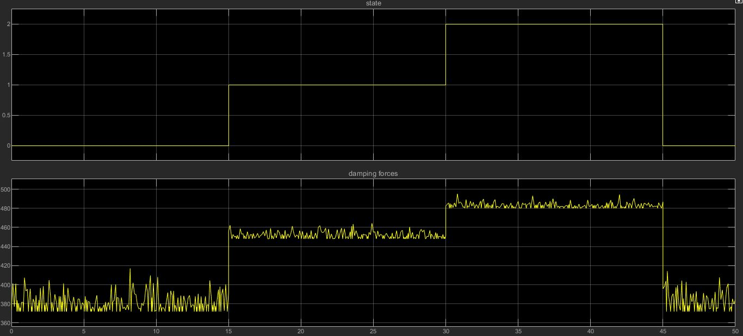

Figure 6: Output of the model

At state 0 i.e. comfort, the current value is 0.2 A.

At state 1 i.e. sport, the current value is 0.4 A.

At state 2 i.e. sport+, the current value is 0.6 A.  
  
Because of body roll that occurs during normal driving, the current values have been adjusted slightly to account for it.   
The fluctuating current values are sent to the look-up table, which outputs fluctuating damping forces.  
  
The model conveys the following:

* Depending upon the driving mode, a base value of damping forces can be selected.
* Small adjustments around the base value can be made by countering the body roll movements.
* Comfort is the softest setting and the damping forces are minimal. This is because of the low value of coefficient of damping.
* Sport+ is the hardest setting and the damping forces are maximum. This is because of the high value of coefficient of damping.

The model is a very high level implementation of the semi-active damping system using MR dampers and is only used to convey the concept of semi-active damping.

## References:

*Books:*

1. ‘**Vehicle Suspension Systems and Electromagnetic Dampers’** by S*. Kashem, R. Nagarajah, M. Ektesabi – Springer - 2018.*

*Technical Papers:*

1. **‘Advances in Active Suspension Systems’** by *A. Goyal et. al* *– IJCRT - 2017.*
2. **‘Semi-Active Suspension Systems** **from research to mass market** **– A Review’** *by AMA Soliman and MMS Kalidas – Journal of Low Frequency Noise Vibration and Active Control - 2019.*
3. **‘Semi-Active Suspension Systems using magnetorheological fluids’** by *Arne Lind – Norwegian Defence Research Establishment - 2008*
4. **‘A Study of Electric Vehicle Suspension Control System based on an -Improved Half-Vehicle Model’** by *J.Cao et al.* *– International Journal of Automation and Computing - 2007.*
5. **‘The Adaptive Suspension Vehicle’** by *K. J. Waldron and R. B. McGhee* *– IEEE Control Systems Magazine - December 1986.*

*Internet Sources:*

1. <https://en.wikipedia.org/wiki/Active_Body_Control>
2. <https://media.daimler.com/>
3. <https://newsroom.lexus.eu/lexus-upgrades-gs-f-and-rc-f-with-adaptive-variable-suspension/>
4. <https://www.thetruthaboutcars.com/2016/02/ford-uses-continuously-controlled-damping-take-shock-damage-potholes/>
5. <https://www.cjponyparts.com/resources>
6. <https://www.lord.com/products-and-solutions/active-vibration-control/industrial-suspension-systems/how-does-mr-damper-work>